UK Ecomuseum Area’s
Purple line denotes ecomuseum area, if no line (Flodden & Spodden) then whole of map shown. See websites for more details.

CATERAN – Perthshire/Angus Scotland https://cateranecomuseum.co.uk/
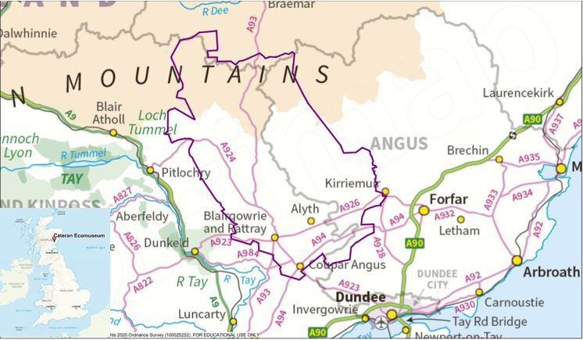

ECOAMGEDDFA – Llyn Peninsula, Wales https://www.ecoamgueddfa.org/?lang=en
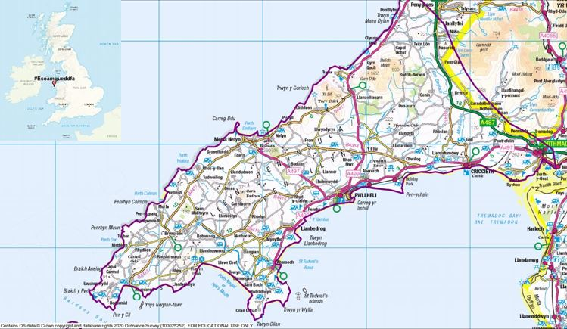

FLODDEN 1513 – Scottish Border/Northumberland https://www.flodden1513ecomuseum.org/
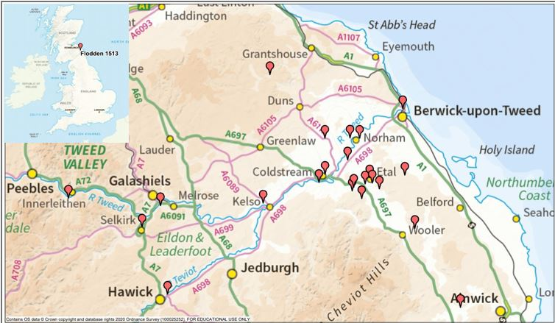

SKYE ECOMUSEUM – Isle of Skye, Scotland https://skyeecomuseum.com/
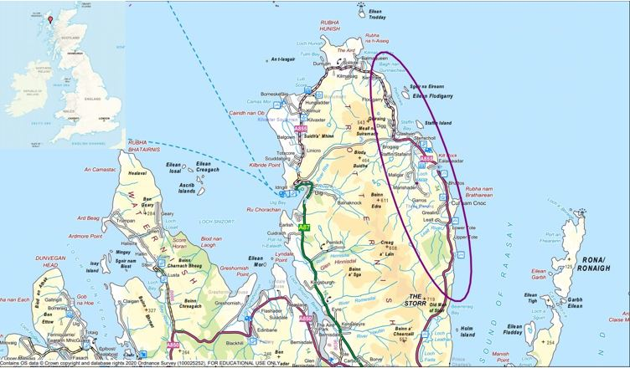

SPODDEN VALLEY REVEALED – Lancashire, England http://midpenninearts.org.uk/programmes/spodden-valley-revealed/
